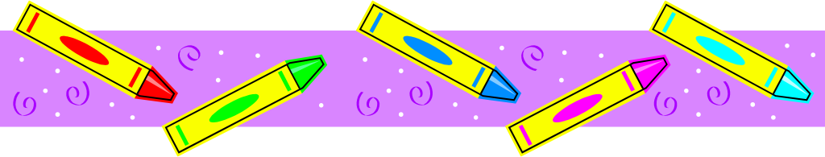
Supply List – September 2025-2026
Mrs. Hoxhaj
Grade 1
3 primary lined composition notebooks (not college ruled)
3 packages #2 Ticonderoga pre-sharpened pencils
1 small box Crayola crayons
1 package Crayola washable markers
1 package Crayola colored pencils
1 pair child sized Fiskar scissors
1 package Elmer’s glue sticks (4 or more glue sticks package)
2 sharpeners with receptacle (Bostitch or Staedtler brand)
2 GREEN two-pocket poly folders with bottom pockets
4 boxes of Kleenex tissues
4 Clorox tubs of disinfecting wipes
1 LARGE plastic pencil box for supplies (place your child’s name on this box)
1 backpack-NO wheels
1 clipboard
1 pair headphones for laptop use (these stay in school and label with name)
1 refillable PLASTIC water bottle

Grade 2
Please purchase ALL of the above and add/change:
2 BLUE two-pocket poly folders with bottom pockets (instead of green)
1 large homework pad (lined- this can be a composition notebook, too)
Second graders do not need to purchase a clipboard.

Grade 3
Please purchase ALL items in first grade section and add/change:
2 RED two-pocket poly folders with bottom pockets (instead of green)
1 large homework pad (lined-this can be a composition notebook, too)
Third graders do not need to purchase a clipboard.

●Keep your store receipts! Please label all items with your child’s first and last name.

**ALL STUDENTS: Please have your child create a collage on one composition notebook (back and front) using family photos, pictures from magazines, favorite foods, places, words and pictures from vacation brochures, etc. Please use a glue stick. This will be your child’s writer’s journal. Due 9/5/2025!

- Summer reading list (online books count) and work will be collected the first week of school in exchange for a positive reward and to be part of a reading celebration!

•If your child has any food allergies, or takes medication that we need to know about, please send an updated note/prescription from your doctor to explain.

● Please provide extra snacks and water each day for snack time. The teacher will not provide snacks.
•Please purchase a set of supplies to keep at home; for homework and project purposes. (Pencils, construction paper, a sharpener, crayons, glue, scissors, and an in./cm. ruler).

